## 结果截图

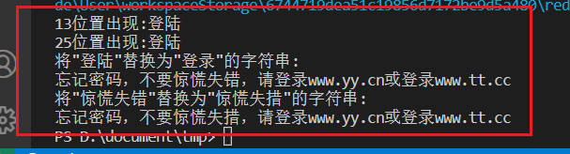

## 代码截图

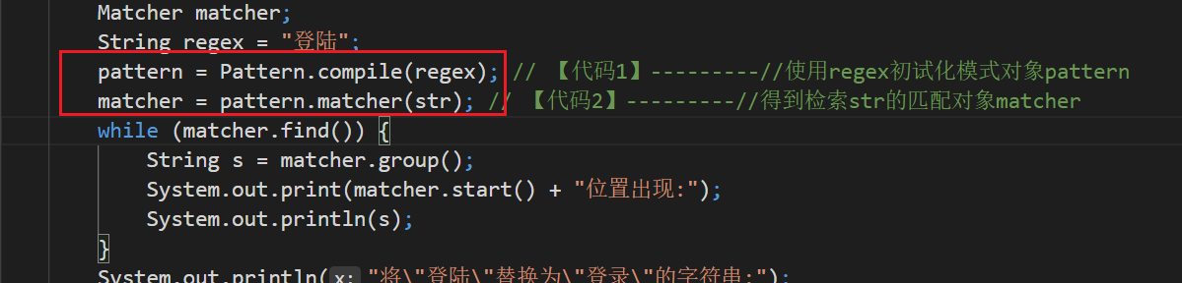

## 源码

package chapter8_5;

import java.util.regex.*;

public class ReplaceErrorWord {

public static void main(String args[]) {

String str = "忘记密码，不要惊慌失错，请登陆www.yy.cn或登陆www.tt.cc";

Pattern pattern;

Matcher matcher;

String regex = "登陆";

pattern = Pattern.compile(regex); // 【代码1】---------//使用regex初试化模式对象pattern

matcher = pattern.matcher(str); // 【代码2】---------//得到检索str的匹配对象matcher

while (matcher.find()) {

String s = matcher.group();

System.out.print(matcher.start() + "位置出现:");

System.out.println(s);

}

System.out.println("将\"登陆\"替换为\"登录\"的字符串:");

String result = matcher.replaceAll("登录");

System.out.println(result);

pattern = Pattern.compile("惊慌失错");

matcher = pattern.matcher(result);

System.out.println("将\"惊慌失错\"替换为\"惊慌失措\"的字符串:");

result = matcher.replaceAll("惊慌失措");

System.out.println(result);

}

}